YOU’VE BEEN FLOCKED!

SURPRISE! As part of a fundraiser being conducted by the
Houston High School Band, these flamingos will nest in your yard for 24-48 hrs.

REMOVAL INSTRUCTIONS:
  - $20 donation- Removes the flock from your yard
  - $30 donation- Removes the flock, and then “flock a friend”
  - $50 donation- Flock removed, flock forwarded, and flock blocked
from coming back to your yard.

TO DONATE:
Go to www.thehoustonband.com, click on the fundraising tab, and then click on the “Donate” button to pay via PayPal or with a credit card. If you are forwarding the flock, add the name and address in the “special instructions” box before donating.
*The Band Boosters is a 501(c)(3) charitable organization.
Please call or text Amy Burgess at 901-832-8900 to arrange a flocking, a flocking removal or for flocking insurance.

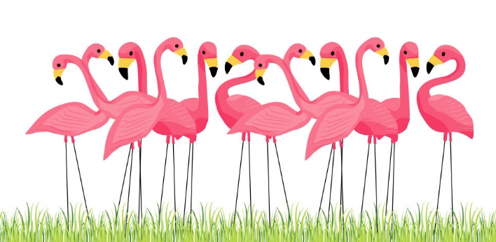
**Note: The Houston Band is working hard to raise funds to cover our expenses, and we appreciate any donation that you can make. However, if you are unable to donate at this time, contact our team of flocking experts to remove the birds at no cost. We hope that you've enjoyed this surprise flocking and appreciate the spirit and good will with which it was intended.

